Stage 2 Cost Recovery Impact Statement Template
The stage 2 Cost Recovery Impact Statement (CRIS) template is designed specifically for proposals seeking agreement on cost recovery levels.
The stage 2 template can replace the Regulatory Impact Statement (RIS) requirements. Consult your Treasury vote analyst to first decide whether this is appropriate. The template will follow the same QA process as an RIS.
The purpose of the stage 2 template is to provide a place to clearly present the information decision makers require in order to make a decision on cost recovery levels.
The diagram below illustrates the information requirements for each of the cost recovery stages
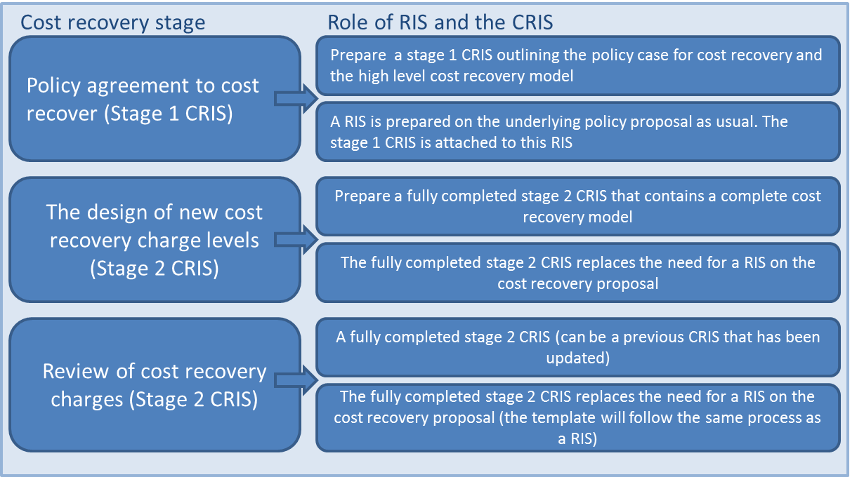
Guidance to assist you in completing the cost recovery template:
Treasury Guide: Guidelines for Setting Charges in the Public Sector
Controller and Auditor-General Guide: Charging fees for public sector goods and services

Stage 2 Cost Recovery Impact Statement
Title of Proposal/Name of Issue

Agency Disclosure Statement
This Cost Recovery Impact Statement has been prepared by [name of agency].
It provides an analysis of options to [state in one sentence what problem the options in this paper seek to address].
[Paragraphs describing the nature and extent of the analysis undertaken, explicitly noting:
- key gaps
- assumptions
- dependencies
- any significant constraints, caveats or uncertainties concerning the analysis,
- any time constraints, including the nature and cause of the constraints, and
- any further work required before any policy decisions could be implemented.]
[Please note that the Agency Disclosure Statement should address the reliance that decision-makers may place on the analysis. It should not be an executive summary of the CRIS.]
This CRIS was originally published on [date] and was updated on [date] following a review of [summary of the scope of the review].
[Name and designation of person responsible for preparing the CRIS]

[Signature of person] [Date]

Executive summary
- A short outline of the CRIS and key conclusions—preferably in less than one page.

Status quo
- A description of the activity and why it is undertaken.
- What policy outcomes will the activity achieve?
- What is the rationale for government intervention?
- What relevant policy decisions have been made? Substantial detail is not required here, but a clear explanation of what has been agreed to and what has not been agreed to is needed.
- The statutory authority to charge ie, the Act that gives the power to cost recover.
- Is this a new or amended fee?

Reviews of cost recovery charges
If this proposal is a review of existing charges then the following questions need to be addressed:
- What is the reason for the review? eg, scheduled review or addressing a problem with current user charge levels
- Describe the existing cost recovery policy eg, what activities does it cover?
- Where is the current schedule of charges located? Ie, the current fees and charges that are currently in place.
- Identify the problem(s) with carrying on under the status quo.

Cost Recovery Principles and Objectives
See section 1.3 “Key considerations in cost recovery” in the Treasury’s ‘Guidelines for Setting Charges in the Public Sector’ for more information.
- What are the underlying principles that apply to and guide the cost recovery proposal? These principles should come from the Act that gives authority to cost recover and the OAG guidelines. A feasible option must meet the stated principles.
- The principles can be stated with a brief description of each provided. For example:
  - Authority: A public entity must have legal authority to charge a fee and must operate within the scope of the empowering provision.
  - Efficiency: The user charge should be no higher than necessary to produce a good or service to the desired level of quality. The design of the charge should incentivise efficiency ie, keeping costs down and the quality of the service high.
- What are the objectives of the cost recovery proposal? These objectives should be a combination of the Cost Recovery principles, intent of the policy that is being cost recovered and the objectives in the Treasury guidance. For example:
  - Equity (also described as fairness): The user charge is being paid by the appropriate people. Thought will have to be given to whether the risk exacerbator and/or the beneficiary pays for the good or service.
  - Maintain desired level of safety. The user charge needs to be at a level that will allow the regulator to fully carry out their functions and not undermine the safety of the regime (particularly relevant for safety inspection practices).
- The objectives will be used to assess the selected option for effectiveness in the future.

Policy Rationale: Why a user charge? And what type is most appropriate?
See section 3 “The policy rationale for cost recovery” in the Treasury’s ‘Guidelines for Setting Charges in the Public Sector’ for more information.
- Why is cost recovery appropriate for the activity (over and above the legal authority to charge) ie, why should it be third party funded rather than funded by the Crown?
- What is the nature of output from the activity (the characteristics of the good or service) eg, public/private/club goods (see section 3.2 of Treasury guidelines)?
- Is full or partial cost recovery being proposed? What is the rationale for proposing full or partial cost recovery?
- What type of charge is being proposed eg, fee, levy, hourly charge? What is the rationale behind selecting this type of charge?
- Who will pay the cost recovery charges? Include data on the number and size of businesses, individuals etc, if possible.
- Assessment of proposed user charge against objectives.

The level of the proposed fee and its cost components (cost recovery model)
See section 5 “Bringing it all together - Design of cost recovery” in the Treasury’s ‘Guidelines for Setting Charges in the Public Sector’ for more information.
- Design of cost recovery charges. What are the proposed charge levels? If this is a review, compare them to the current levels and have a column with the percentage change.
- Outputs and processes of the activity. What are the main cost drivers of the activity? ie, what are the outputs of the activity and the business processes that are used to produce those outputs? This should be itemised and explained in a table or similar method (see figure 1.1 and figure 1.2 in annex for example).
- Costing the activity. Breakdown of the user charge, for example: direct costs eg, staff salaries (including on-costs, such as training, superannuation and leave) and indirect costs eg, salaries of staff in corporate roles such as finance and human resources, (see figure 1.3 in annex for example).
- Present forecast total revenue, ideally over the first three year (see figure 1.4 in annex for example). If this is a review existing revenue information should also be provided.
- Present estimates of expenses and revenue for the activity. The estimates should illustrate the potential for revenue and expenses to align.
- Discuss how changes in the underlying assumptions will affect financial estimates.
- If this proposal is a review and an increase in user charges is proposed, is pursuing options for efficiency/productivity improvements, or making changes to levels of expected service delivery, or vary the expected memorandum account balance, without any change in fee levels a feasible option?

Impact analysis
See section 3.4 “Impacts and incentives in cost recovery regimes” in the Treasury’s ‘Guidelines for Setting Charges in the Public Sector’ for more information.
- What is the impact of the proposed fee? How many people, businesses etc. will be effected? What is the change in cost they will face?
- Impacts/risks on the regulator eg, service performance risks.
- Expected effects on demand for services.
- What is the evidence that the cost recovery arrangements are reasonable? Eg, comparison to privately provided services or an international comparison if feasible (see figure 1.5 in annex for example).

Consultation
See section 2.5 “Consultation approach” of the Treasury’s Regulatory Impact Analysis handbook for more information.
- Explain who has been consulted, what form the consultation took and what options were canvassed.
- Outline key feedback received, with particular emphasis on any significant concerns that were raised about the preferred option and how the proposal has been altered to address these concerns (or if not, why not).
- If there was limited or no consultation undertaken, the reasons why should be explained (note: this should also be explained in the Agency Disclosure Statement).

Conclusions and recommendations
- Summarise and present the cost recovery proposal.
- It is not mandatory for an agency to recommend or reject a particular option. But where an agency does so, it should explain and justify their recommendation in the RIS.

Implementation plan
See section 6 “Implementation, monitoring and managing cost recovery regimes” in the Treasury’s ‘Guidelines for Setting Charges in the Public Sector’ for more information.
- Summarise how the proposed option(s) will be given effect, including transitional arrangements.
- Describe how implementation risks will be being mitigated.
- Describe the steps that are being taken to minimise compliance costs.
- Describe how the proposal would interact with, or impact on, existing regulation, including whether there is scope to reduce or remove any existing regulations.
- Outline the enforcement strategy that will be implemented to ensure that the preferred option achieves its public policy objectives.

Monitoring and evaluation
See section 6 “Implementation, monitoring and managing cost recovery regimes” in the Treasury’s ‘Guidelines for Setting Charges in the Public Sector’ for more information.
- Outline plans for monitoring, benchmarking and evaluating the effectiveness of the preferred option, including performance indicators and how the necessary data will be collected.
- What performance metrics will be established to assess the performance of the regulator? This is important to prove that activities are operating efficiently and meet the ‘open book’ approach to cost recovery. For example:
  - Require x% of all applications for licences to be completed within x working days.
  - Notifications are provided when the service or good is not going to be provided by the proposed time.
  - For variable charges: an indication of expected cost, how this relates to the average, and if it is different what is the reason.
- Having performance metrics in place is particularly important for variable charges eg hourly fees.

Review
See section 6.7 “Reviews of cost recovery regimes” in the Treasury’s ‘Guidelines for Setting Charges in the Public Sector’ for more information.
- The expectation is that cost recovery regimes are reviewed at least every three years. Explain how and when it will be reviewed and what the review process will involve (and if no plans for review, the reasons why). This might be as simple as updating this template.

Version control
Other version | Date | Link

Annex 1: Best practice examples
Figure 1.1: The cost drivers of an activity, broken down by outputs and business processes
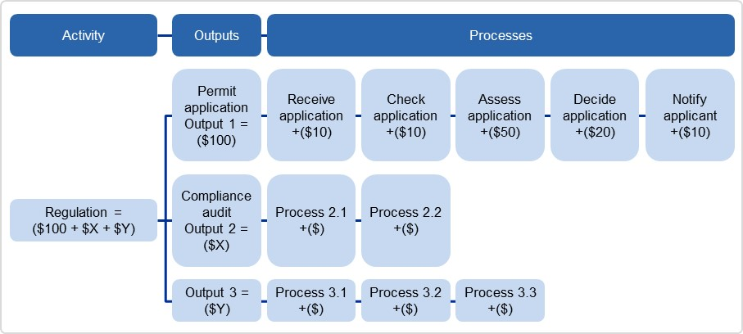
Source: Australian Government Cost Recovery Guidelines, Pg. 33. http://www.finance.gov.au/sites/default/files/australian-government-cost-recovery-guidelines.pdf

Figure 1.2: Breakdown of User Charge Example: Proposed 10-year adult e-passport fee breakdown
Source: Passport Canada Fee-for-Service Proposal, Pg. 20
Figure 1.3: Allocating and apportioning costs to a cost object (eg, an output)
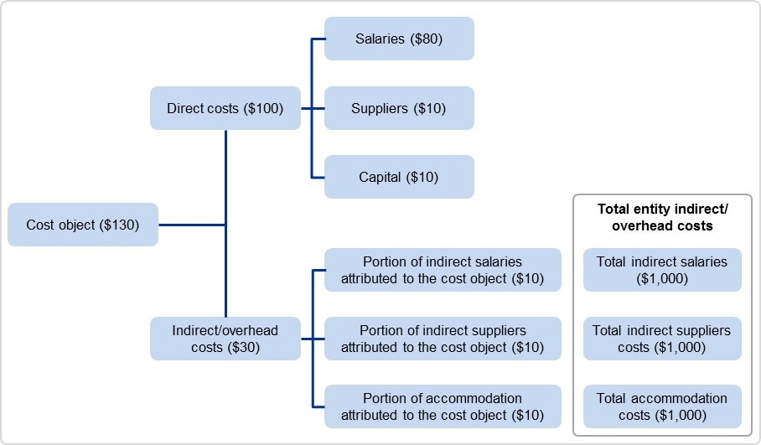
Activity
Source: Australian Government Cost Recovery Guidelines, Pg. 36. http://www.finance.gov.au/sites/default/files/australian-government-cost-recovery-guidelines.pdf

Figure 1.4: Forecast fee revenue example (2014/15)
Application | Fees ($) | No. of Applications | Revenue  ($000)
Initial Provider Registration | $22,000 & $85,000 | 18 | 396
Renewal of Provider Registration | $20,000 & $75,000 | 38 | 1,310
Initial Course Accreditation | $9,000 (1st course/app.),  $6,300 (2nd course+/app.) | 157 | 1,151
Renewal of Course Accreditation | $8,000 (1st course/app.),  $5,600 (2nd course+/app.),  $1,000 (teach out) | 207 | 1,231
CRICOS Registration | $5,000 | 2 | 10
CRICOS Re-Registration | $5,000 | 25 | 125
Other CRICOS Matters | $2,500 for 2 specific changes | 28 | 70
Self-Accreditation Authority Fee | Partial SAA ($0 & $10,000),  Full ($0 & $22,000) | 4 | 88
TOTAL |  | 479 | 4,381
Source: Tertiary Education Quality and Standards Agency Cost Recovery Implementation Statement, Pg.12
Figure 1.5: Comparison of international passport fees
Service | United Kingdom | United States | New Zealand | Australia | Canada (proposed)
Service | Fee comparison
Validity period | 10 years | 10 years | 5 years | 10 years | 10 and 5 years
ePassport | Yes | Yes | Yes | Yes | Yes
Regular adult fee | £77.50  ($122) | US$135  ($139) | NZ$153.30 ($120) | AU$233  ($238) | 10-year: $160 5-year: $120
Children's fees (approximate % of cost of adult passport) | £49 (63%) ($77) | US$105 (78%)  ($108) | NZ$80.70 (53%)  ($64) | AU$117 (50%)  ($119) | $57 (60%)
Fee per year of validity | £7.75  ($12) | US$13.50 ($14) | NZ$30.66  ($24) | AU$23.30  ($24) | 10-year: $16  5-year: $24
Source: Passport Canada Fee-for-Service Proposal, Pg. 21

Examples of problems with current user charges which means change is required: better management of memorandum account, changes in input prices, changes in level of demand, service composition change, desire for better service performance.
A principle is a general rule that should be used to guide cost recovery design, a feasible option must meet the stated principles. An objective is more of a goal that a specific cost recovery proposal should meet, the recommended option does not need to meet all of the objectives.
If a stage 1 template was completed the cost recovery model should be consistent with the high-level cost recovery model. Differences should be noted and explained.

