Stage 1 Cost Recovery Impact
Statement Template
The stage 1 Cost Recovery Impact Statement (CRIS) template is designed specifically for proposals seeking policy agreement to cost recover, but not yet seeking policy agreement on cost recovery levels (ie, agreement on cost recovery levels will be sought at a later date).
The stage 1 template does not replace the Regulatory Impact Statement (RIS). The stage 1 template should be attached to the Statement or Summary.
The purpose of the stage 1 template is to provide a place to clearly explain the policy rationale for cost recovery and to provide a high level cost recovery model, which includes estimates of the cost recovery levels. The RIS is the document that contains the analysis on the proposal that cost recovery is being sought for. The CRIS is the document that contains the analysis for why cost recovery is appropriate.
The diagram below illustrates the information requirements for each of the cost recovery stages:
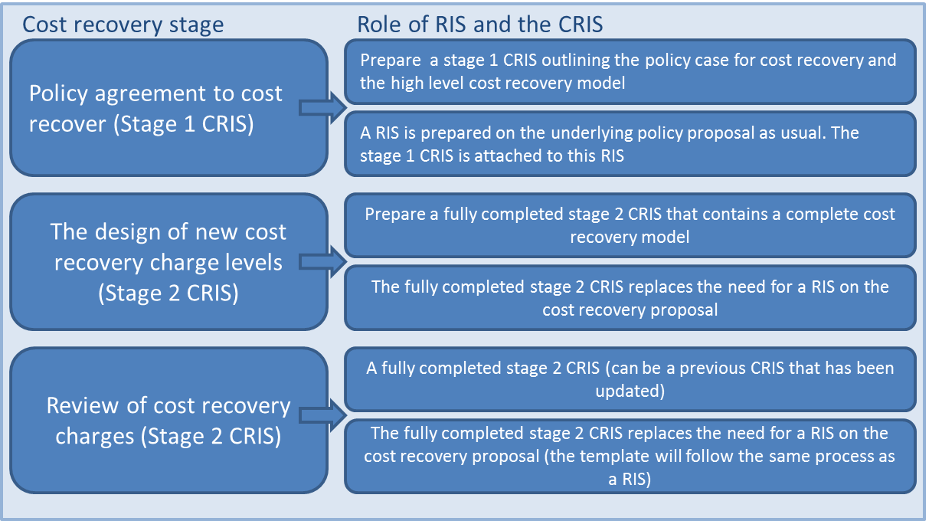

Guidance to assist you in completing the cost recovery template:
Treasury Guide: Guidelines for Setting Charges in the Public Sector
Controller and Auditor-General Guide: Charging fees for public sector goods and services

Stage 1 Cost Recovery Impact Statement
Title of Proposal/Name of Issue

Status quo
- A description of the activity and why it is undertaken.
- What policy outcomes will the activity achieve?
- What is the rationale for government intervention?
- What are the relevant policy decisions that have been made? Substantial detail is not required here, but a clear explanation of what has been agreed to and what has not been agreed to is needed.
- What is the statutory authority to charge ie, the Act that gives the power to cost recover?
- Is this a new or amended fee?

Policy Rationale: Why a user charge? And what type is most appropriate?
See section 3 “The policy rationale for cost recovery” in the Treasury’s ‘Guidelines for Setting Charges in the Public Sector’ for more information.
- Why is cost recovery appropriate for the activity (over and above the legal authority to charge) ie, why should it be third party funded rather than funded by the Crown?
- What is the nature of output from the activity (the characteristics of the good or service) eg, public/private/club goods (see section 3.2 of Treasury guidelines)?
- Is full or partial cost recovery being proposed? What is the rationale for proposing full or partial cost recovery?
- What type of charge is being proposed? Eg, fee, levy, hourly charge. What is the rationale behind selecting this type of charge?
- Who will pay the cost recovery charges? Include data on the number and size of businesses, individuals etc, if possible.

High level cost recovery model (the level of the proposed fee and its cost components)
See section 5 “Bringing it all together - Design of cost recovery” in the Treasury’s ‘Guidelines for Setting Charges in the Public Sector’ for more information.
- What are the estimated charge levels? At stage 1 it is unlikely levels are known with 100 per cent confidence, if this is the case ensure that any assumptions are made explicit.
- What are the main cost drivers of the activity? What are the outputs of the activity and the business processes that are used to produce those outputs? This should be itemised and explained in a table or similar method (see figure 1.1 and figure 1.2 in annex for example).
- Breakdown of the user charge, for example: direct costs eg, staff salaries (including on-costs, such as training, superannuation and leave) and indirect costs eg, salaries of staff in corporate roles such as finance and human resources (see figure 1.3 in annex for example)
- Present estimates of expenses and revenue for the activity. The estimates should illustrate the potential for revenue and expenses to align.
- Discuss how changes in the underlying assumptions will affect financial estimates.

Consultation
- Explain who has been consulted (or who will be consulted), what form the consultation took and what options were canvassed.
- Outline key feedback received, with particular emphasis on any significant concerns that were raised about the preferred option and how the proposal has been altered to address these concerns (or if not, why not).
Explain how consultation will be managed for the rest of the process (that is, while the detailed cost recovery model is developed, and through implementation).

Annex 1: Best practice examples
Figure 1.1: The cost drivers of an activity, broken down by outputs and business processes
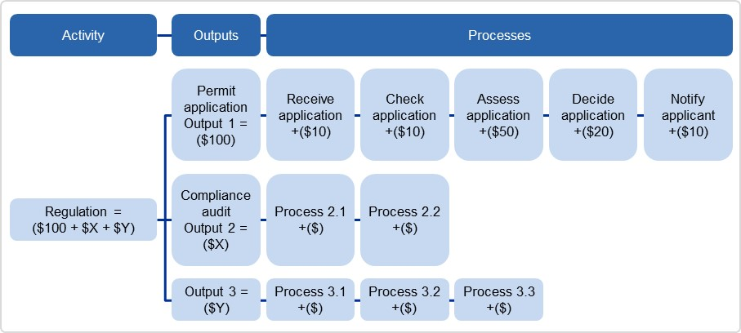
Source: Australian Government Cost Recovery Guidelines, Pg. 32. http://www.finance.gov.au/sites/default/files/australian-government-cost-recovery-guidelines.pdf
Figure 1.2: Breakdown of User Charge Example: Proposed 10-year adult e-passport fee breakdown
Source: Passport Canada Fee-for-Service Proposal, Pg. 20
Figure 1.3: Allocating and apportioning costs to a cost object (eg, an output)
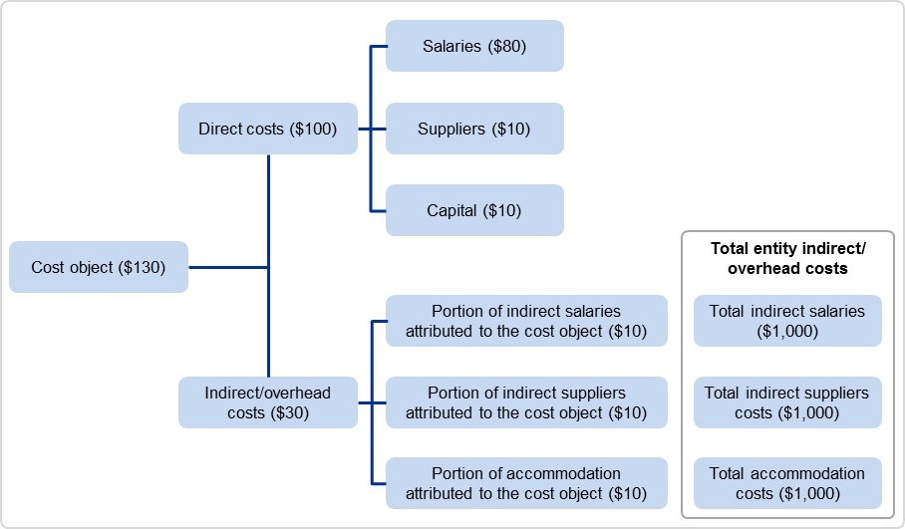
Source: Australian Government Cost Recovery Guidelines, Pg. 32. http://www.finance.gov.au/sites/default/files/australian-government-cost-recovery-guidelines.pdf

