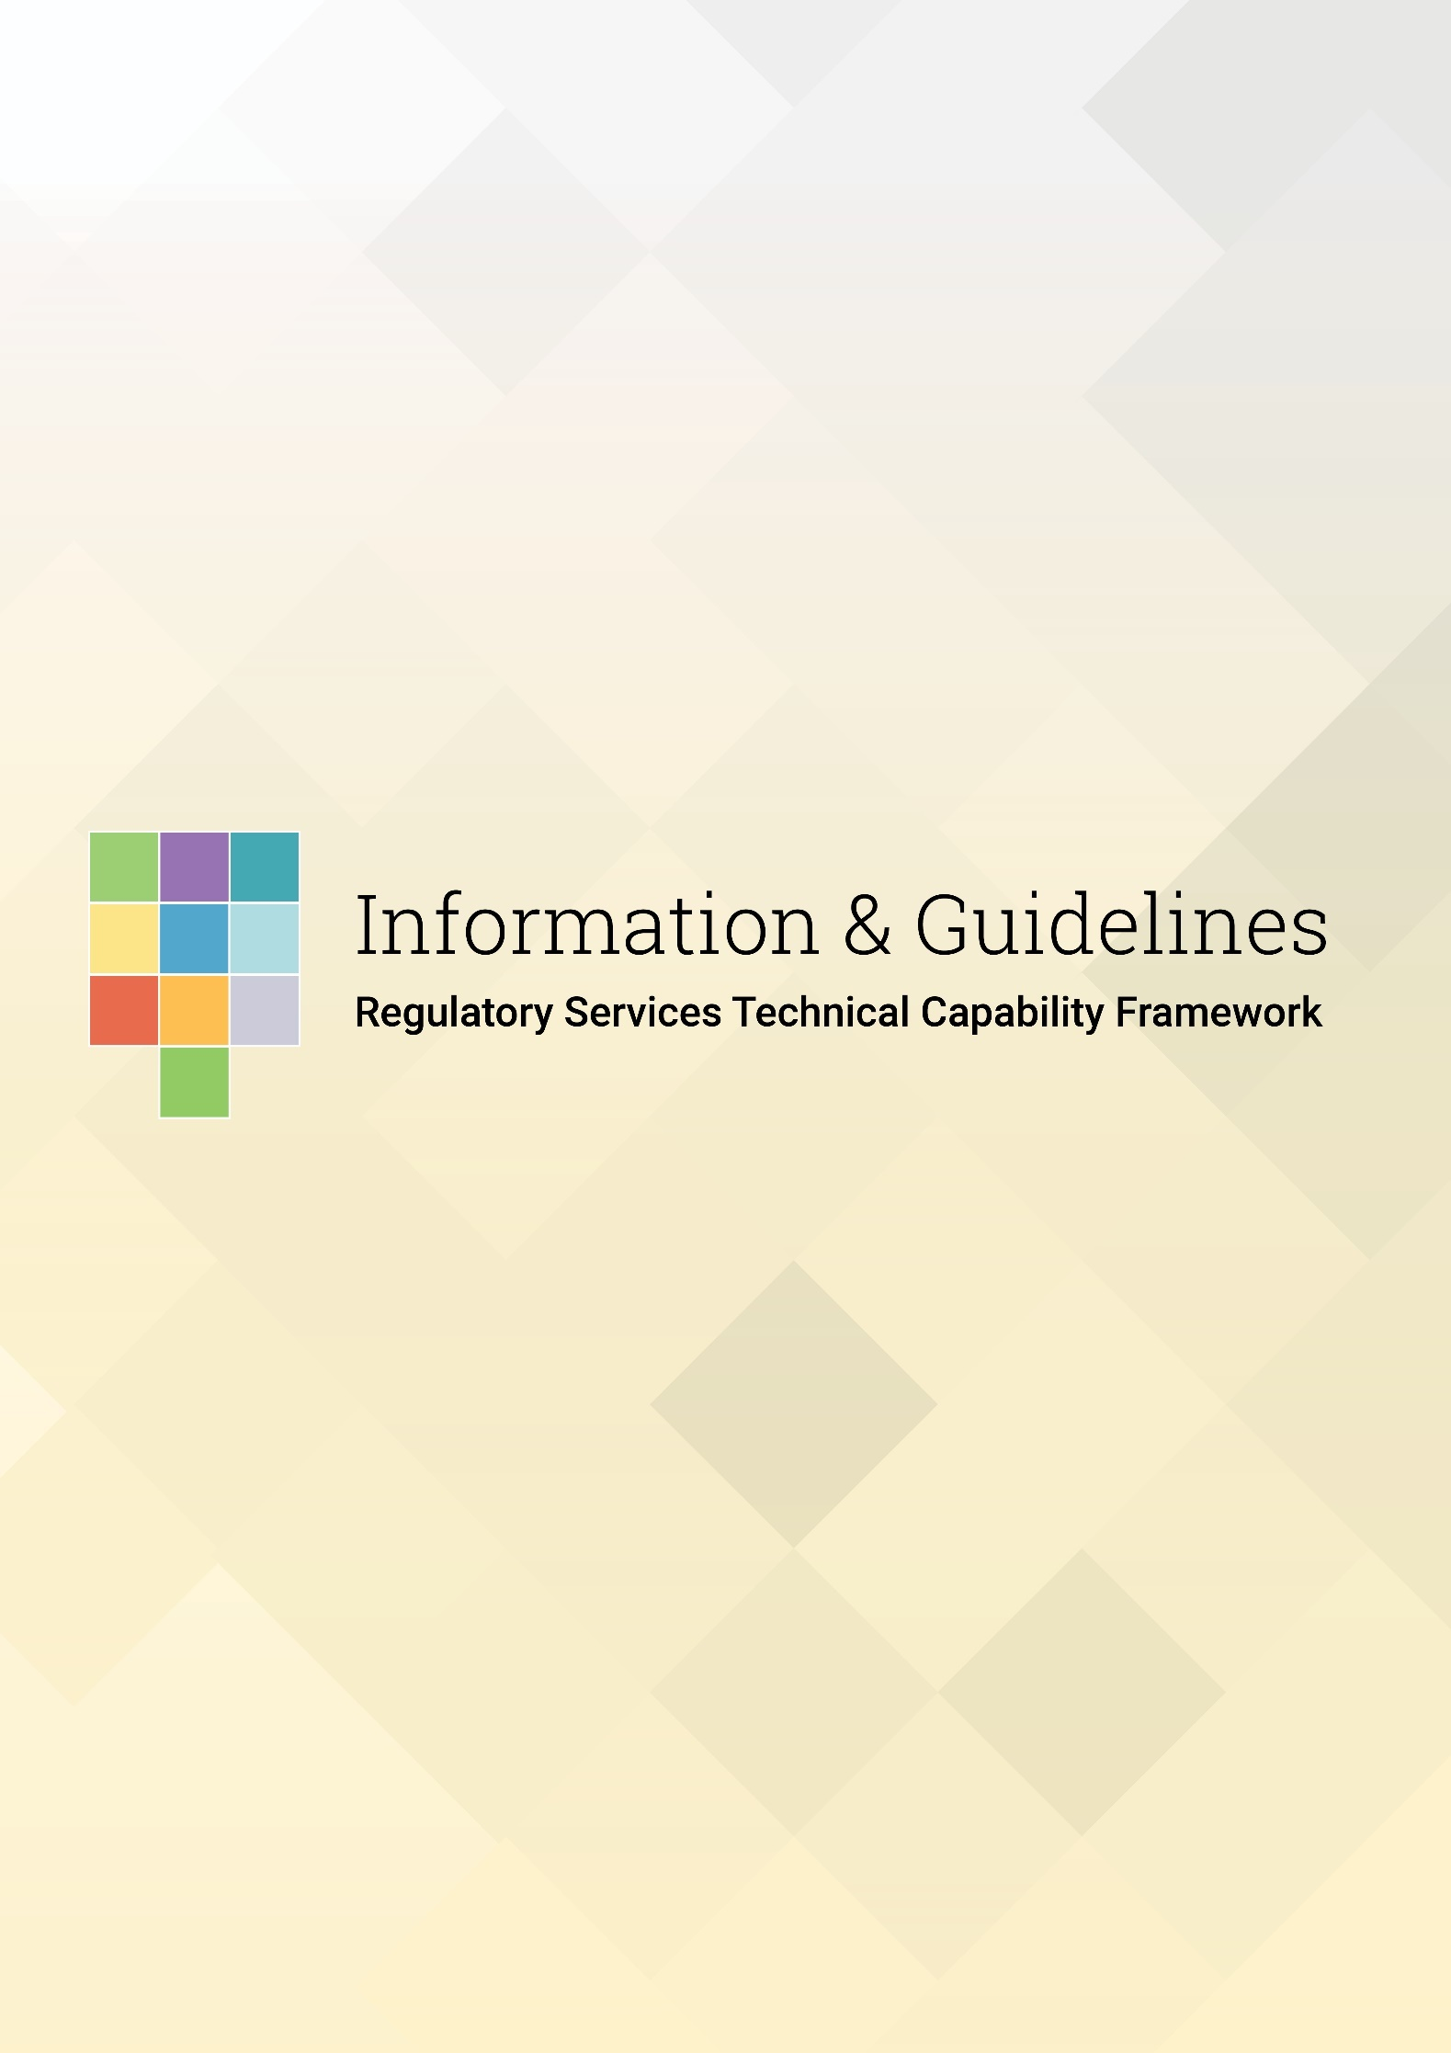

**Regulatory Services Technical Capabilities**

***Empowering our people to be the best they can be***

|  |  |  |
| --- | --- | --- |
| Regulatory Theory | Understanding Regulatory Systems | Regulatory Practice |
| **Teamwork and Networking** | **Change and Innovation** | **Understanding the Machinery of Government** |
| **Analytical Skills** | **Communicate with Influence** | **Digital Savvy** |
|  | **Planning and Work Management** |  |



About the RS Capability Framework

**Purpose**

The Regulatory Services (RS) Technical Capability Framework promotes continuous improvement across RS by identifying the capabilities (i.e. skills, knowledge and experience) required for RS teams.

**About the framework**

The environment we work in as regulators is constantly changing. New technologies, new risks and new risk creators mean that staff may have to acquire new skills, a different set of skills, or a combination of different skills to do their job, and to meet our outcomes as professional Regulators.

Workforce Capability matters for the successful achievement of our strategic outcomes, and RS is committed to building and sustaining a high-performance workforce both now and in the future.

By providing an environment that supports, nurtures, and develops employees to realise their full potential, we will work to ensure that our employees have the required skills, knowledge, attributes and behaviours needed to perform well in their role both now and into the future.

This framework provides managers and staff with a basis for learning and development conversations, progression and decision-making.

The capabilities outlined in this document reflect the integration of knowledge, attributes, and experience that when used appropriately will drive effective performance.

When working through this guide please note the term ‘regulator’ applies to all RS roles not just the regulator role in RS.

**The Regulatory Services Technical Capability Framework**

The RS Technical Capability Framework has 10 technical capabilities that apply across all Regulatory Services staff.

|  |  |  |  |
| --- | --- | --- | --- |
| RS Technical Capabilities | | | |
| 1 | Regulatory Theory | 6 | Change & Innovation |
| 2 | Understanding Regulatory Systems | 7 | Analytical Skills |
| 3 | Regulatory Practice | 8 | Communicates with Influence |
| 4 | Understanding the Machinery of Government | 9 | Digital Savvy |
| 5 | Teamwork & Networking | 10 | Planning & Work Management |

**The Technical Capabilities**

The technical capabilities work together to provide an understanding of the knowledge, skills and abilities that are required to be developed by individuals and teams to create high levels of performance in line with our strategic direction. These capabilities are required of staff in their current role as well as future roles they may want to grow into.

**Descriptors for each capability**

Each technical capability has a description of what the capability looks like, at three proficiency levels that show a progressive increase in complexity and skill. The level for each of the capabilities will vary depending on the functions of the role.

Proficiency levels give a sense of progression by transitioning from well-defined processes at the Developed and Established levels, to an emphasis on designing/leading work at the Advanced level.

Descriptors found in lower levels are automatically included in each higher level, with an expectation that there will be an improved application of lower levels (e.g. an awareness of what did/didn’t work, and how things can be done better).

**The proficiency levels and behavioural descriptors are:**

|  |  |
| --- | --- |
| Capability Level | The Behavioural Descriptors |
| **Developed** | Able to handle medium-complexity tasks with limited risk and sensitivity. Any problem definition will be clear, and the scope of the work well defined. The work may be stand-alone or part of a larger or more complex issue. |
| **Established** | Able to work on and lead large programmes involving sensitivity, conflict, or risk with high intellectual connectivity where the scope of the work may be ambiguous.  They can work with minimal supervision and have well-developed knowledge of the area of expertise for which they are responsible.  They provide leadership to more junior colleagues by reviewing their work and providing feedback and coaching or more formal mentoring arrangements. |
| **Advanced** | A recognised expert providing professional leadership to others.  They act as role models for less experienced colleagues, offering support, leadership, and guidance.  They work on complex, multi-sector issues with significant sensitivity and risk and can integrate issues and develop approaches to support this. Their sophisticated skills enable them to handle complex relationships across multiple stakeholders.  There is an expectation of being able to respond quickly to change and to deliver quickly. |

**Behavioural Descriptors/Indicators**

Behavioural Descriptors/Indicators are a set of statements that illustrate the type of behaviours expected at each level.

The behavioural descriptors/indicators for each proficiency level are intended to be observable. They should be interpreted as demonstrative for each capability and are not exhaustive, nor prescriptive. When read collectively, the behavioural indicators provide a reasonable understanding of what a particular level of capability ‘looks like’.

The capability framework does not remove the responsibility for employees and managers to have meaningful professional development and career management conversations on a regular basis. Rather, the framework is a common tool to support these types of conversations.

**An example of a capability proficiency level and the descriptors.**

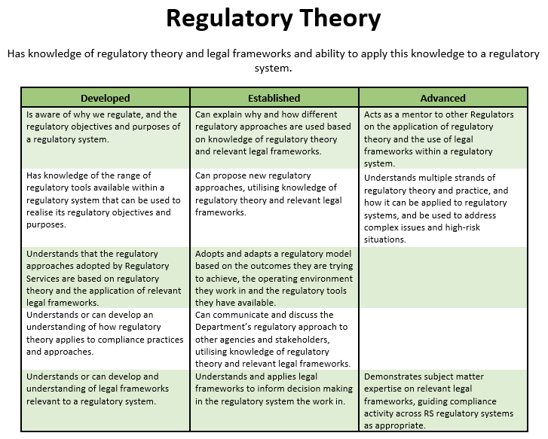

Reflect a progressive increase in complexity and skill

**Levels**

**Behavioural descriptors/indicators**

A set of statements illustrating the types of behaviours expected at each level

## Specific learning and development for each capability

We are currently capturing specific ***known*** learning and development opportunities that will help people progress through the proficiency levels. We are also capturing ***completed*** learning and development opportunities through a learning matrix that will provide an RS wide view of learning activities. Where there is no learning and development in place already, we will look to source or develop learning activities as required.

The learning activities should cover a cross-section of learning methods and follow the 70:20:10 rule:

**On the job learning**

Also described as informal or self-directed learning. Individuals learn from experience, problem solving and practice

**Learning through others**

Learning through social and collaborative interaction with peers, role models, mentors and coaches

**Formal learning**

Structured, directed learning. The learning objectives and content is controlled and managed by the group

**Methods of learning and development include:**

**10% - Formal learning**

* Structured courses
* Workshops
* Webinars
* On-line learning/e-learning
* Qualifications

**20% - Learning through others**

* Communities of practice
* Subject matter networks
* Collaboration platforms/networks
* Coaching
* Mentoring
* Feedback

**70% - On the job learning**

* Action Learning and Problem solving
* Placements, secondments and job rotations
* Shadowing, self-directed and incidental/unplanned learning
* Projects and special assignments
* Podcasts/videos

**The DIA Capability Framework**

The DIA Capability Framework is one part of individual, organisational, and team development activities that link between each other. It is our organisation capability framework that informs performance planning and assessment and provides managers with tools and resources to assess their team’s performance against agreed objectives and goals.

The RS Technical Capability Framework fits in with the Regulatory Services capability development such as job skills, team skills, processes, technical knowledge, different levels of practice needed for our work.  It focuses on providing our staff with the right development so that they can do their jobs well and be the best they can be.

The RS Technical Capability Framework links into the performance review timeline when people leaders review how staff have progressed against their performance and development plan objectives. This is especially the case when considering development plans that have been informed by the RS Technical Capability Framework and how the development completed has contributed to improved performance and progression.

The diagram below outlines how the frameworks work together.

**Regulatory Services**

**Individual**

**Department**

**JD**

**Engagement**

**activitie**s

**Development plan**

**How to use the RS Technical Capability Framework**

Using this framework as a basis for learning and development planning begins with staff and people leaders understanding the capabilities that are relevant to the individual’s role, and the proficiency level they are expected to be working at.

**People Leaders can use the framework to:**

* Assess the proficiency level necessary for individual/team’s work
* Identify skills gaps between an individual’s current level of proficiency and the level required by the individual’s work, by using the descriptors
* Identify learning/development opportunities to address these gaps
* Inform career progression/planning and development pathways
* Identify learning/development opportunities relevant to staff for future roles of interest
* Inform the design of new roles
* Help people leaders articulate the capability requirements of a role being recruited for
* Inform strategic planning

**Staff can use the framework to:**

* Self-assess their current proficiency level against what they need by using the descriptors
* Plan their development with their manager
* Consider career growth and analyse the required capabilities of a new role.

**The purpose of the RS Technical Capability Framework**

It is important that staff understand that this framework is a development tool, it is not a performance management tool. Its purpose is to understand the development a staff member may need to be the best they can be in the role they are working in. It informs progression planning and identifies staff who are working above the proficiency level expected of them, enabling a tailored approach to be applied to their learning and development, in line with their career aspiration and goals.

When meeting with their staff, people leaders through great conversations will set the expectations of the meeting and work through each capability that is applied to the individual’s role, to map the capability level they are currently working at.

People leaders and staff will discuss any identified gaps and using the 70:20:10 model consider learning and development opportunities to support the individual staff member’s development and progression.

Development needs and opportunities will be included in the staff member’s PDP and will inform development pathways and succession planning.

There are resources available to help support people leaders in their development conversations with staff. Access to these will be provided to people leaders as part of the deployment of the framework. You can find out more about the capabilities included in the framework in the resource below.

* [The RS Technical Capability Framework - Technical Capabilities](https://dia.cohesion.net.nz/Sites/RGS/_layouts/15/DocIdRedir.aspx?ID=Y33QDE6WQQWD-6-531)